Cloud Account and Deploy a VM
Tasks
1.
Set up a free trial account on any major cloud provider (AWS, Azure, or Google Cloud) and deploy a basic virtual machine (VM) using default security settings.
2.
Use an open-source vulnerability scanner like OpenVAS or Nikto to scan your deployed cloud VM for security vulnerabilities and save the scan report.
3.
Identify at least three vulnerabilities from your scan report, and for each, document the vulnerability, its potential impact, and a recommended mitigation strategy in a table format.<br><br><em><strong>Hint:</strong> For mitigation, consider changes to firewall rules, patching, or disabling unused services.</em>
4.
Pick one vulnerability from your findings and implement the recommended mitigation (for example, update a package, close an open port, or adjust a firewall rule), then rerun your vulnerability scan to verify if the issue is resolved.
5.
Share your vulnerability scan results and mitigation steps with your group using a shared document or chat, and discuss how these issues might appear in popular apps like Zomato or Paytm if left unaddressed.

Answer : Task 1: Create a Free Cloud Account and Deploy a VM
Step 1: Create an AWS Free Tier Account
What is AWS?
AWS (Amazon Web Services) is a cloud platform where you can create servers, databases, storage, and many other services.
- Go to the AWS website.
- Sign up for a Free Tier account.
- Verify your phone number and payment method.
- Log in to the AWS Management Console.

Step 2: Launch an EC2 Virtual Machine
EC2 is AWS's virtual machine service.
- Open EC2 Dashboard.
- Click Launch Instance.
- Enter a name like:
Security-Lab-VM
- Choose
- Ubuntu Server 22.04 LTS
- Instance Type
t2.micro
(Free Tier eligible)
- Create a new Key Pair.
Download the .pem file and save it.
- Network Settings
Use the default settings.
Allow:
- SSH (22)
- HTTP (80)
Leave the rest as default.
- Click Launch Instance.
Wait until the instance status becomes Running.

Step 3: Connect to the VM
From your terminal:
chmod 400 mykey.pem

ssh -i mykey.pem ubuntu@YOUR_PUBLIC_IP
Example:
ssh -i mykey.pem ubuntu@54.xxx.xxx.xxx
If you successfully log in, Task 1 is complete.

Task 2: Scan the VM Using OpenVAS
Option A (Recommended)
Install Greenbone/OpenVAS on another Ubuntu VM.
Why another VM?
A vulnerability scanner scans another machine over the network.
Update Ubuntu
sudo apt update
sudo apt upgrade -y

Install Docker
sudo apt install docker.io -y

Run Greenbone Community Edition
(You can use the official Greenbone Community Edition deployment instructions.)
Once installed,
Open the browser
https://SCANNER-IP
Login using the generated admin credentials.

Create a Scan
- Create Target
Enter your VM's public IP.
Example:
54.xxx.xxx.xxx

Create a Task
Select
Full and Fast Scan
Run it.
Wait until it reaches 100%.

Export the report as
PDF
or
HTML
Save it.

Option B (Much Easier)
Use Nikto.
Install:
sudo apt install nikto -y
Run:
nikto -h http://YOUR_PUBLIC_IP
Example:
nikto -h http://54.xxx.xxx.xxx
Save report:
nikto -h http://54.xxx.xxx.xxx -o report.txt

Task 3: Identify Three Vulnerabilities
Your report will differ depending on the VM configuration, but here is an example table.
Vulnerability | Potential Impact | Recommended Mitigation
SSH Port (22) open to the internet | Attackers can attempt brute-force logins | Restrict SSH access to your own IP in the security group
Apache/Nginx server version disclosed | Attackers can identify known exploits for that version | Hide server version and keep packages updated
Missing security updates | Vulnerable software may allow remote code execution or privilege escalation | Update the operating system and installed packages regularly
If you used Nikto, you may also see:
- Directory listing enabled
- Missing security headers
- Default files exposed
Those are also valid vulnerabilities.

Task 4: Mitigate One Vulnerability
Let's fix:

Open SSH Port
Current Rule
SSH
0.0.0.0/0
This means everyone on the internet can attempt to connect.

Fix
Go to
EC2

↓

Security Groups

↓

Inbound Rules
Edit
Replace
0.0.0.0/0
with
YOUR_PUBLIC_IP/32
Save.

Or Update Packages
sudo apt update
sudo apt upgrade -y

Scan Again
Run:
nikto -h http://YOUR_PUBLIC_IP
or rerun the OpenVAS scan.
If the issue is fixed, it should no longer appear or its severity should be reduced.
Take screenshots before and after for your report.

Task 5: Share With Your Group
You can use:
- Google Docs
- Microsoft Word Online
- WhatsApp
- Microsoft Teams
- Slack
Share:
- Scan report
- Vulnerability table
- Mitigation steps
- Before/after scan screenshots

Discussion Example
Zomato
If the web server reveals its software version, attackers could exploit known vulnerabilities to gain unauthorized access or disrupt services.
Paytm
If SSH is exposed to the internet without restrictions, attackers could launch brute-force attacks. If successful, they might gain unauthorized access to backend systems, risking sensitive financial data.
General Impact
Leaving vulnerabilities unaddressed can result in:
- Data breaches
- Service outages
- Unauthorized access
- Financial losses
- Damage to customer trust

Sample Report Structure
- Introduction
  - Objective: Deploy a cloud VM, scan for vulnerabilities, and implement one mitigation.
- Cloud Setup
  - AWS Free Tier
  - Ubuntu 22.04
  - EC2 t2.micro
  - Default security group
- Vulnerability Scan
  - Tool used: OpenVAS or Nikto
  - Target: VM public IP
  - Report attached
- Vulnerability Findings
  - Include the table with three vulnerabilities, impacts, and mitigations.
- Mitigation
  - Describe the selected fix (e.g., restricting SSH access or updating packages).
  - Include commands or configuration changes made.
- Verification
  - Rerun the scan.
  - Compare results before and after mitigation.
- Discussion
  - Explain how similar issues could affect applications like Zomato or Paytm if left unresolved.
- Conclusion
Summarize the importance of regular vulnerability scanning and timely remediation.

1. Example: AWS EC2 Launch Instance
This is what the Launch Instance page in AWS looks like.
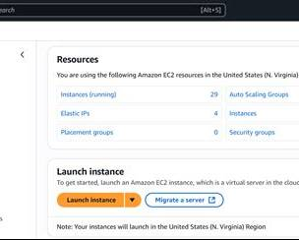
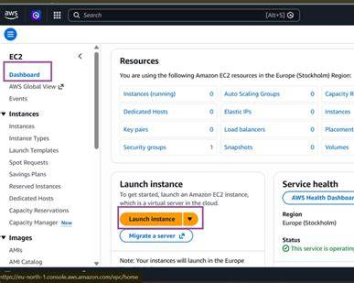
You can follow the official AWS beginner tutorial for launching an EC2 instance:
AWS EC2 Getting Started Guide

2. Example: Nikto Vulnerability Scan Output
A Nikto scan looks similar to the examples below.
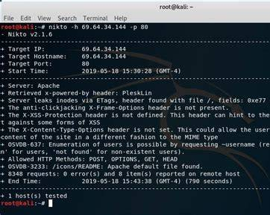
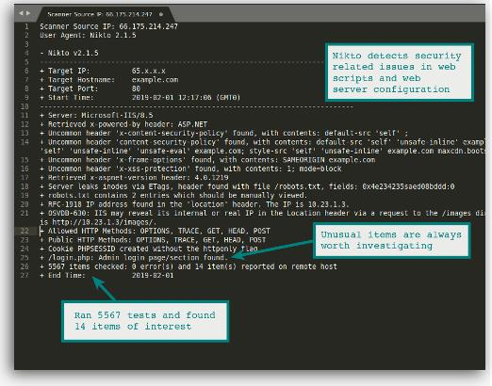
Typical command:
nikto -h http://YOUR_PUBLIC_IP
Example output:
+ Target IP: 18.212.100.50
+ Target Port: 80

+ Server: Apache/2.4.41 (Ubuntu)

+ Retrieved x-powered-by header: PHP/8.1

+ X-Frame-Options header is not present.

+ X-Content-Type-Options header is not set.

+ Allowed HTTP Methods: GET, POST, OPTIONS, HEAD

+ 6500 requests: 0 error(s) and 5 item(s) reported

3. Example Vulnerability Table
You can include a table like this in your report.
Vulnerability | Risk Level | Impact | Mitigation
SSH Port 22 open to everyone (0.0.0.0/0) | Medium | Attackers can attempt brute-force login attacks. | Restrict SSH access to only your IP address.
Missing X-Frame-Options Header | Medium | Website may be vulnerable to clickjacking attacks. | Configure the web server to send the X-Frame-Options header.
Missing X-Content-Type-Options Header | Low | Browsers may incorrectly interpret file types, increasing some attack risks. | Add the X-Content-Type-Options: nosniff header.

4. Example Mitigation

Before
AWS Security Group:
SSH (22)

Source:
0.0.0.0/0
Everyone on the internet can attempt to connect.

After
SSH (22)

Source:
203.0.113.25/32
Only your computer can connect.

Run the scan again.
Example:
Previous Scan:
SSH exposed to everyone

New Scan:
SSH restricted
Issue resolved

5. Sample Discussion (Zomato / Paytm)
You can write something like this:
If vulnerabilities such as open SSH ports, outdated software, or missing HTTP security headers are left unresolved, attackers could exploit them to gain unauthorized access, steal user information, or disrupt services. In applications like Zomato, attackers might access customer accounts or order information. In Paytm, similar weaknesses could expose sensitive financial data or allow unauthorized access to backend systems. Regular vulnerability scanning, timely software updates, and secure firewall configurations help reduce these risks.

6. Sample Report Format

Cloud Security Assignment

Name:
Roll Number:

Cloud Provider:
AWS

Virtual Machine:
Ubuntu 22.04 LTS
Instance Type: t2.micro

Scanner Used:
Nikto

Target IP:
18.xxx.xxx.xxx

----------------------------------------------------

Findings

1. SSH Port Open
Impact:
Brute-force attacks are possible.

Mitigation:
Restricted SSH to my IP.

Status:
Fixed

----------------------------------------------------

2. Missing X-Frame-Options Header

Impact:
Clickjacking attack possible.

Mitigation:
Configured Apache security headers.

Status:
Pending

----------------------------------------------------

3. Missing X-Content-Type-Options Header

Impact:
Browser MIME sniffing attack.

Mitigation:
Added "nosniff" header.

Status:
Pending

----------------------------------------------------

Conclusion

The VM was scanned successfully.
One vulnerability was mitigated by restricting SSH access.
The second scan confirmed the issue was resolved.

